**“Phonebook Management System”**



**Department of computer science and engineering**

**BANGLADESH UNIVERSITY OF BUSINESS AND TECHNOLOGY (BUBT)**

**RUPNAGAR, MIRPUR-2, Dhaka-1216, BANGLADESH**

**23 RD February, 2020**

**“Phonebook Management System”**



**A Project**

Submitted to the department of computer science in partial

Fulfillment of the requirements for the degree

Of

**Bachelor of Science**

In

**Computer Science and Engineering**

A project report

**Submitted by:**

Mosraful Habib 172

Intake: 41 section: 4

Semester: Spring-2020

**Supervised by:**

**Md. Anwar Hussen Wadud**

Lecturer

Department of Computer Science &amp; Engineering

BANGLADESH UNIVERSITY OF BUSINESS AND TECHNOLOGY (BUBT)

RUPNAGAR, MIRPUR-2, Dhaka-1216, BANGLADESH

**ACKNOWLEDGMENT**

First, we express our heartiest thanks and gratefulness to almighty for his divine blessing makes us possible to complete the final year project successfully. The success and outcome of this project required guidance and assistance thorn some people and we are extremely privileged to have this all alone the completion of our project. All that we have done is only due to such supervisor and assistance and we would not forget to thank them.

We really grateful and wish our profound our indebtedness to Md. Anwar HussenWadud Lecturer Department of CSE, Bangladesh University of Business Technology, Dhaka. Deep know ledge keen interest of our supervisor in the field of Hardware Application to carry out this project. His endless patience, scholarly guidance, continual encouragement, constant and energetic supervision, constructive criticism, valuable advice, reading many inferior drabs and correcting them at all stages base made it possible to complete this project.

**ABSTRACT**

This project is intended to develop a phone book application, which will provide easier communication between general member and any people community. The proposed project is a phone book application, which tries to help the all other people to involve various types in our phone. Also in our project, there are three main actors so we defined their activity respectively. First, the user has to login in our system. Then the user fills the form user as a add Add Contact,Search Contact, Delete Contact,View All Contact& Exit. Admits can be approved or cancel the user request if they are not fulfilling the information create event, post notice, send massage to member, moderator & The admits can also be created group chat. Moderator can check the member profile, post event, notice and modify it. Moderator can see event list, member etc. After approving the account, a user can see the facilities. They can see, read, their profile with a personal number. They can see the event material of event according to their number. One of the features of this project is that when a user becomes a member of a club he does not have to open a new account to join another contacts. After the implementation of all functions, the system is tested in different stages and it works successfully as a prototype.

**DECLARATION**

We certify that this project is our original work. No pan of this has been submitted elsewhere partially or fully for the award of any other degree. Any material reproduced in this project has been properly acknowledged.

We declare that this project and the work presented in it are our own and has been generated by as and hereby declare that the project entitled **"Phonebook Management System"**submitted in partial fulfillment of the requirement for the degree of Bachelor of science and Engineering (CSE) of Bangladesh University of Business and Technology (BUBT). is our won work and that it contains no material which has been accepted for the award to the candidate(s) of any other degree or diploma, except where due reference is made in the text of the project. To the best of our knowledge, it contains no materials previously published or written by other person except where due reference is made in the project.

.................... ........................ ................. ..................

Sabila Rahman TamannaTasnim Sadia Afrin Mosraful Habib

ID: 18192103136 ID: 18192103142 ID: 18192103146 ID: 18192103172

**CERTIFICATE**

This is to certify that **Sabila Rahman, TamannaTasnim, Sadia Afrin &Mosraful Habib** of B.Sc. in CSE has completed their project work titled “**Phonebook Management System”**in partial fulfillment for the requirement of B.Sc. in CSE Bangladesh University of Business and 'technology (BUBT) in the year of 2020.

**...............................**

**Project Supervisor**

Md. Anwar HussenWadud

Lecturer

Department of computer Science Engineering (CSE)

Bangladesh University of business and Technology (BUBT)

Mirpur-2 Dhaka-12 I 6. Bangladesh.

**DEDICATION**

We dedicated our dissertation work to our family and helpful Teachers who have motivated, encouraged and supported us throughout the process. And we also dedicate this work to ALLAH Almighty our creator, our source of inspiration, Wisdom, knowledge, and understanding.

**APPROVAL**

This Project **"Phonebook Management System"Sabila Rahman,**ID No: **18192103136**, **TamannaTasnim**, ID No: **18192103142**, **Sadia Afrin**, ID No: **18192103146**, **Mosraful Habib**, ID No: **18192103172** Submitted by Department of Computer Science and Engineering (CSE). Bangladesh University of Business and Technology (BURT) under the supervision of Md. Anwar HussenWadud, Lecturer, Department of Computer Science and Engineering has been accepted as satisfactory for the partial fulfillment of the requirement for the degree of Bachelor of Science (B.Sc. Eng.) in Computer Science and Engineering and approved as to its style and contents.

**........................**

**Supervisor**

Md. Anwar HussenWadud

Lecturer

Department of Computer Science and Engineering (CSE)

Bangladesh University of Business & Technology (BUBT)

Mirpur-2. Dhaka-12 16. Bangladesh.

**COPYRIGHT**

© Copyright Sabila Rahman(18192103136)

TamannaTasnim(18192103142)

Sadia Afrin(18192103146) and

Mosraful Habib(18192103172)

All Right Reserved

**Index**

* **Project Summary…………………………………….01**
* **Introduction…………………………………………..02**
* **Aim of the project…………………………………….03**
* **Advantages & Disadvantages………………………..04**
* **Software & Hardware details………………………..05**
* **Design………………………………………………….05**
* **Header Files…………………………………………...06**
* **Declaring Functions…………………………………..06**
* **Modules………………………………………………..07**
* **Add Contact Function………………………………..**
* **Search Contact Function…………………………….**
* **Delete Contact Function……………………………..**
* **View Contact Function………………………………**
* **Conclusion……………………………………………**

**PROJECT SUMMARY**

It's SDP documentation for anPhonebook Management System. The purpose for this project is to manage the task easily of different club of our university such as the user fills the form user as aAdd Contact,Search Contact, Delete Contact,View All Contact, Exit member & so on. There will be a main admin for the whole system & individual moderator for each prople.

**Keywords:**Add Contact,Search Contact, Delete Contact,View All Contact& Exit

01

**Introduction**

* Phonebook is a very simple mini project in C that can help you understand the basic concepts of functions and file handling. This application will teach you how to add, search, delete,view and exit data to/from the file.
* Adding new records, listing them,search for contacts saved, and deleting the phonebook records are the basic functions which make up the main menu of this Phonebook application.
* Personal information such as name, phone number are asked while adding a record into the Phonebook.
* We have used many functions in this mini project. These functions are easy to understand as their name only signifies their respective operations.

02

**Aim of the project**

* To develop an “Phonebook Management” system using C programming .
* This program is very useful now-a-days to store information under contact number.
* This program also has options to deletion of the entered contact number.

03

**Advantages & Disadvantages**

* It becomes easy for the user to store information(i.e name and contact).
* It is easy for the user to just search his required contact number by just typing name of the contact.
* It is not possible to store detail information(i.e e-mail,address).
* This project can not modify the information.

04

**Software & Hardware details.**

* This Phonebook application is coded and made using the following compilers:
  + Code::blocks
* Size of the code is 2.95 Kb.

**Design**

* The present program consists of the following modules:
  + Preprocessor commands.
  + Function.
  + Variables.
  + Statements & Expressions.

05

**Header files**

* #include<stdio.h>
* #include<windows.h>

**Declaring functions**

* void add_contact();
* void search_contact();
* void delete_contact();
* void view_all_contact();
* void main();
* exit(0);

06

**Phonebook Management System Program will be start:**

Here we use system cls. Then gradually print “Phone Book” then print “Add Contact” then print “Search Contact” then print “Delete Contact” then print “View all Contact” then print “Exit”.

Here we used integer variable option. User used to any option and work this application.

system("cls");

printf("\t*****PHONE BOOK*****\n");

printf("\t 1. Add Contact\n");

printf("\t 2. Search Contact\n");

printf("\t 3. Delete Contact\n");

printf("\t 4. View All Contact\n");

printf("\t 5. Exit\n");

printf("Enter Your Choice: ");

int option;

scanf("%d",&option);

switch(option)

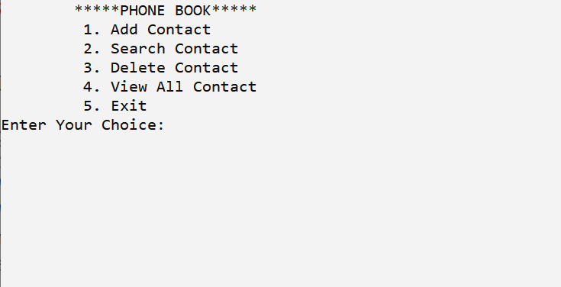

07

**This function displays the user to select his choice of operations:**

Here we use switch case for the user to operators. We use five case. First case add_contact(),

second case search_contact(), 3nd case delete_contact() 4th case view_all_contact(), 5th

case exit().

int option;

scanf("%d",&option);

switch(option)

{

case 1:

add_contact();

break;

case 2:

search_contact();

break;

case 3:

delete_contact();

break;

case 4:

view_all_contact();

break;

case 5:

exit(0);

default:

main();

}

}

08

**Add Contact Function below that:**

Here we use a file to store we use character array for name and integer array for mobile number. Then we close the file.

voidadd_contact()

{

FILE *fp;

fp=fopen("contact.txt","a+");

system("cls");

printf("\t*****ADD CONTACT*****");

printf("\n\tName : ");

char name[100];

scanf("%s",name);

printf("\n\tMob No. : " );

char mob[100];

scanf("%s",mob);

fprintf(fp,"%s %s\n",name,mob);

fclose(fp);

printf("\n\tPRESS ANY KEY TO CONTINUE");

getch();

main();

}

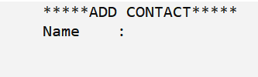

09

10

11

**Search Contact function below that:**

Here we use a function search_contact(), to find contact from the file. First enter the name to search. To search we use while loop and while loop work End of the file. At least we close the file.

voidsearch_contact()

{

FILE *fp;

fp=fopen("contact.txt","r");

system("cls");

printf("\t*****SEARCH CONTACT*****");

printf("\n\t Enter Name : ");

char name[100];

scanf("%s",name);

char name1[100],mob[100];

while(fscanf(fp,"%s %s",name1,mob)!=EOF)

{

if(strcmp(name,name1)==0)

{

printf("\n\tNAME : %s\n",name1);

printf("\n\tMOB NO. : %s\n",mob);

}

}

fclose(fp);

printf("\n\tPRESS ANY KEY TO CONTINUE");

getch();

main();

}

12

13

**Delete Contact function below that:**

Here we use a function delete_contact() to delete contact from file. If we went to delete any contact we enter the name and we use while loop to find the contact and delete this. First we open file and took this contact to ‘temp’ then remove from temp. While loop is working ‘End of the file’.

voiddelete_contact()

{

FILE *fp,*fp1;

fp=fopen("contact.txt","r+");

fp1=fopen("temp.txt","w");

system("cls");

printf("\t*****DELETE CONTACT*****");

printf("\n\t Enter Name : ");

char name[100];

scanf("%s",name);

char name1[100],mob[100];

while(fscanf(fp,"%s %s",name1,mob)!=EOF)

{

if(strcmp(name,name1)==0)

{

continue;

}

fprintf(fp1,"%s %s\n",name1,mob);

}

fclose(fp);

fclose(fp1)

fp=fopen("contact.txt","w");

14

fp1=fopen("temp.txt","r");

while(fscanf(fp1,"%s %s",name1,mob)!=EOF)

{

fprintf(fp,"%s %s\n",name1,mob);

}

fclose(fp);

fclose(fp1);

remove("temp.txt");

printf("\n\tPRESS ANY KEY TO CONTINUE");

getch();

main();

}

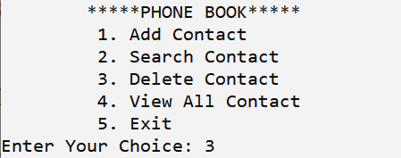

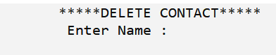

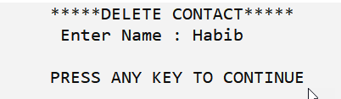

15

**View all Contact function below that:**

Here we use function view_all_contact() to display all the adding contacts and find all contact we use a while loop at the end of the file. Then we close the file.

voidview_all_contact()

{

FILE *fp;

fp=fopen("contact.txt","r");

system("cls");

printf("\t*****ALL CONTACTS*****");

char name1[100],mob[100];

while(fscanf(fp,"%s %s",name1,mob)!=EOF)

{

printf("\n\t NAME : %s",name1);

printf("\n\t MOB NO. : %s",mob);

}

fclose(fp);

printf("\n\tPRESS ANY KEY TO CONTINUE");

getch();

main();

}

16

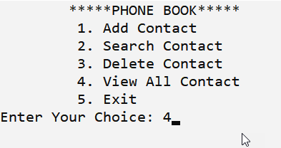

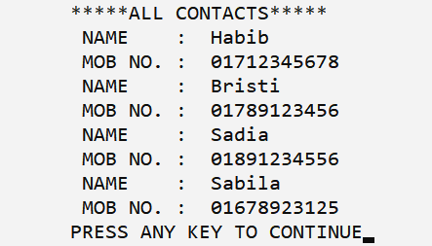

17

18

**Description of feature:**

A new user will have to register by add name and number essentialdetails in order to view, order the contact in the system.A user name will be needed when a user use system.

**PURCHASING Contact:**

The user can add the desired product into his cart by clickingadd to cart option on the product can view his on the cart. All contact added by cart can be viewedin the cart. User can remove an item from the cart by clickingdelete. After confirming the items in the cart, he willpurchasing the products.

**Manage products:**

The administrator canAdd Contact,Search Contact, Delete Contact,View All Contact, Exit.

**Conclusion:**

After analysis at stage of literature review of the “**Phonebook Management System”**it is concluded that the system is effective. Sothis chapter will help us our professional life to develop likethis project with professional.

19

20